Basic unix commands:

1.mkdir command: This command is used to make new directory.

Syntax: mkdir directory name

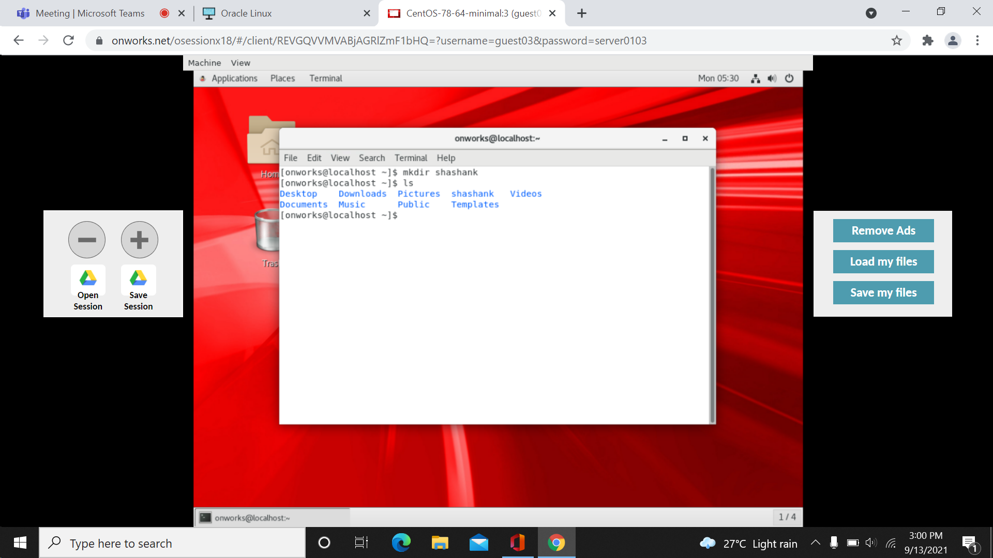

2. cd commmand: this command is used to change the directory.

Syntax: cd directory name

Cd.. -this command points to the previous directory.

Cd /- this command points root directory.

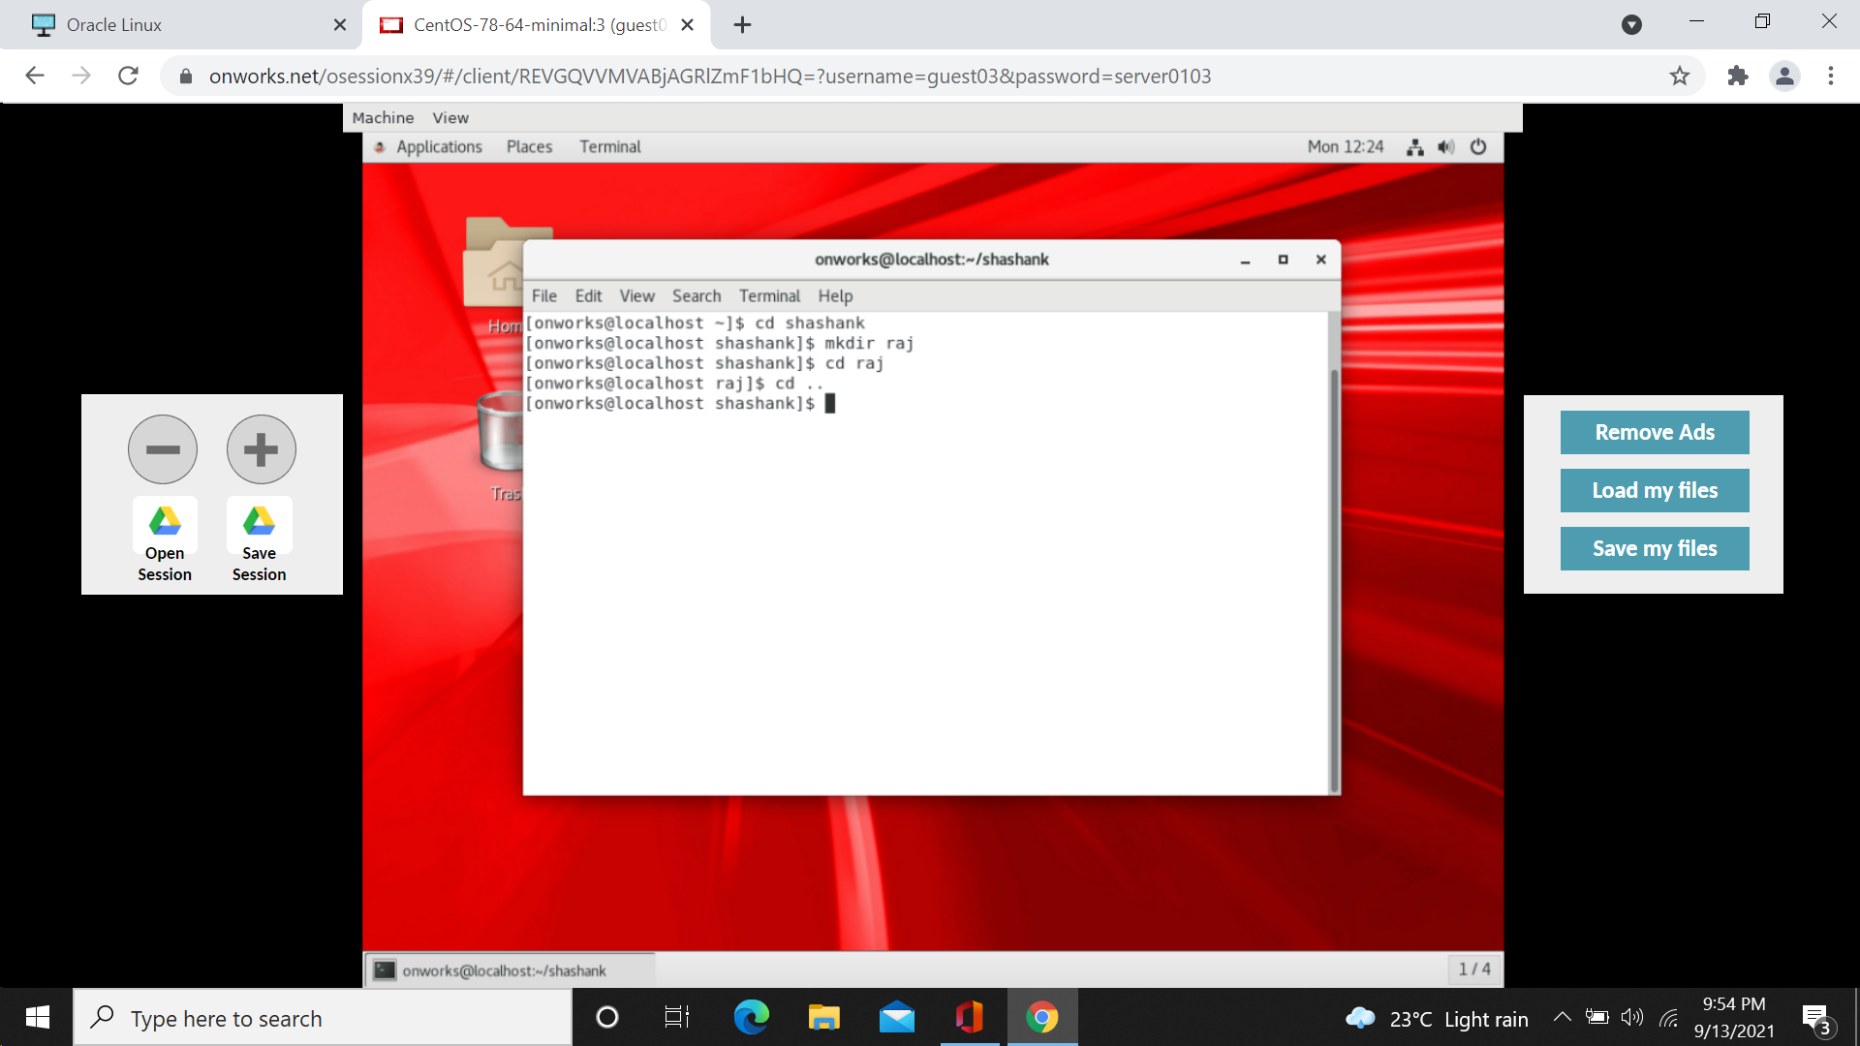

3. ls command: this command is used to list files in a present working directory.

Syntax: ls

Ls –a –this command displays hidden files in a working directory.

Ls –l –this command displays list of files in the pwd with properties.

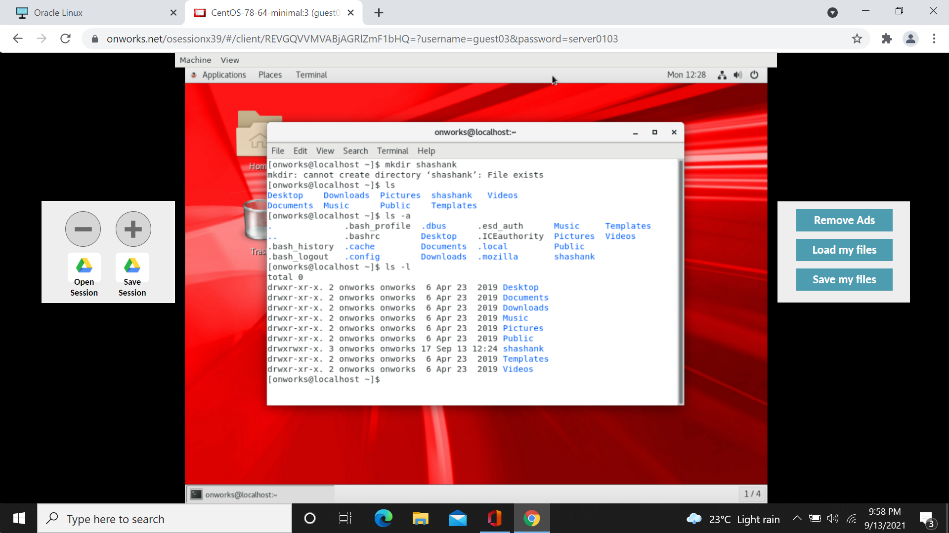

4.pwd command:this command displays present working directory.

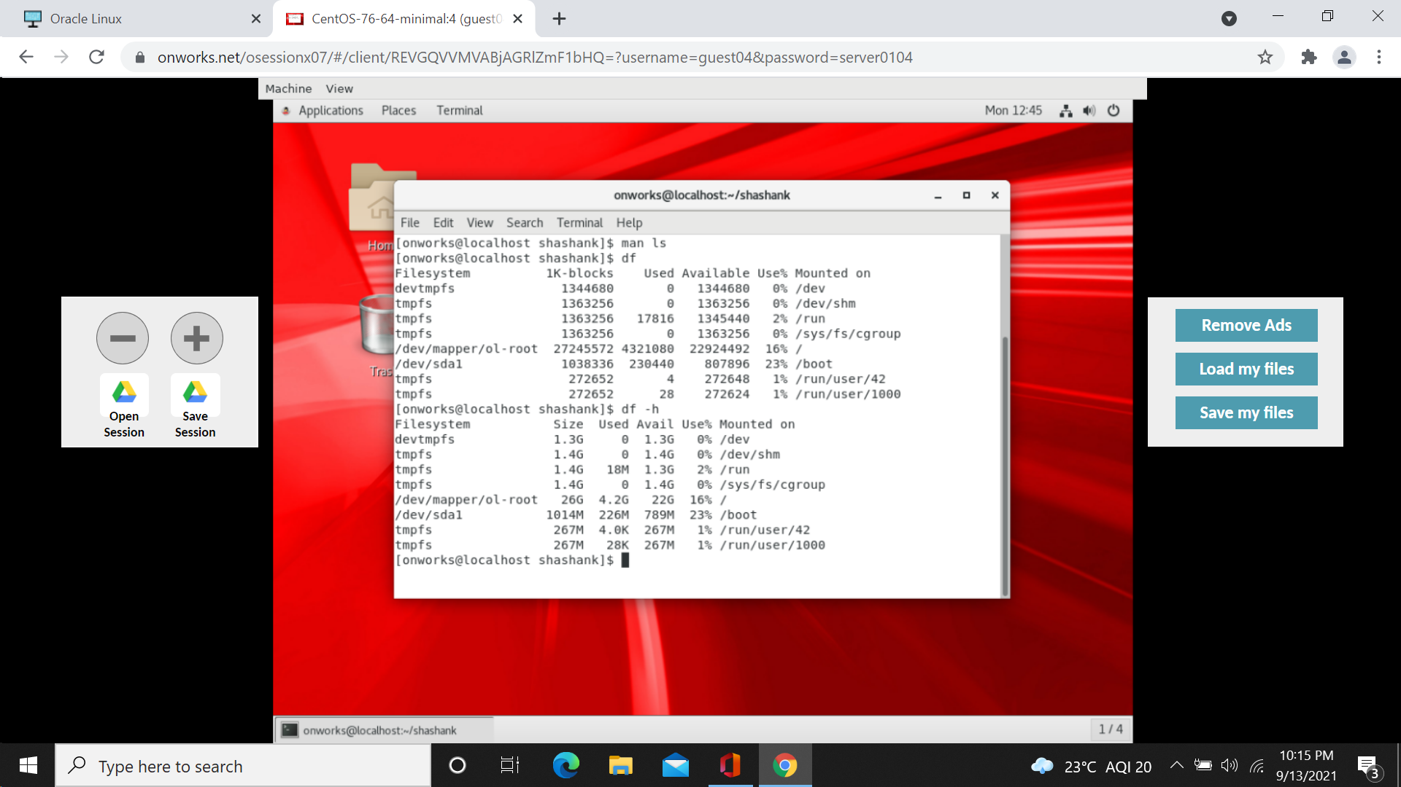

5.man command:this command gives user command manuals.

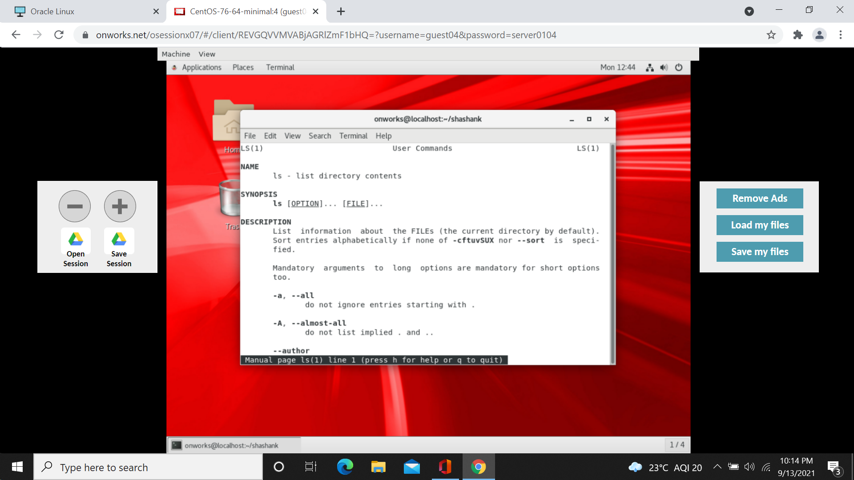

6.df command: df command gives disk space information.

Df –h command gives disk space information in human readable format.



7. ps command: this command gives status of current running process.

Ps –a gives status of hidden process.

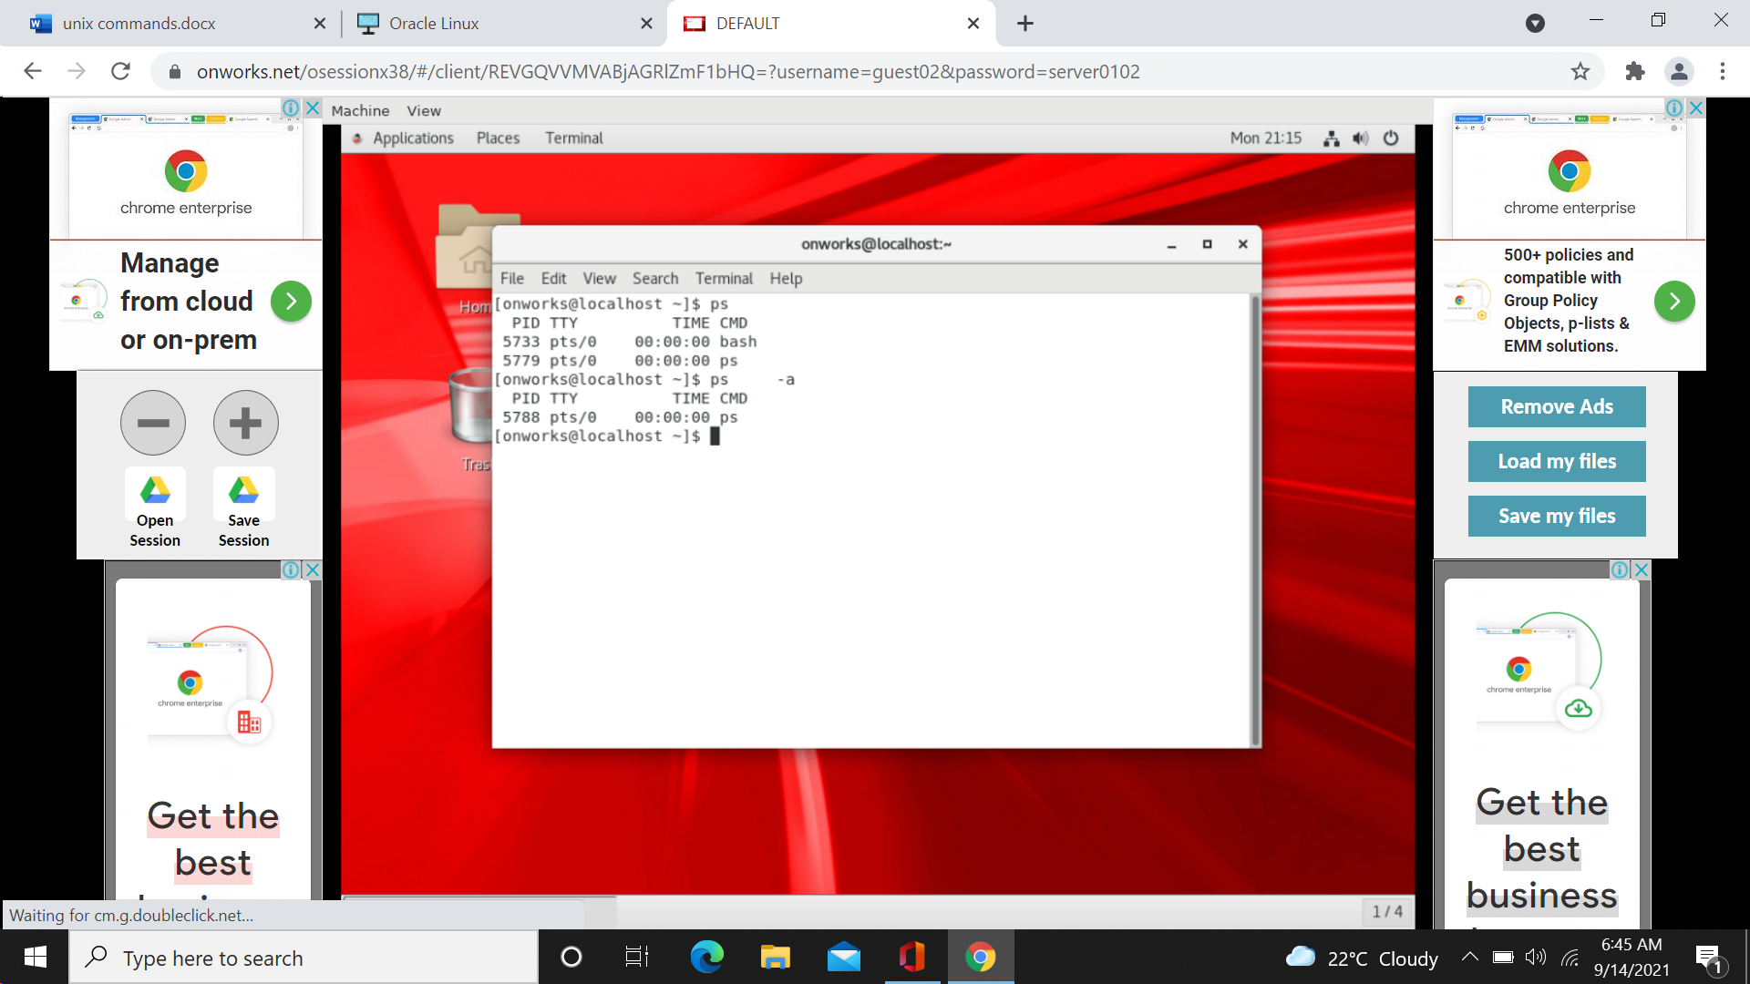

8.gedit command : this command is used to open notepad.

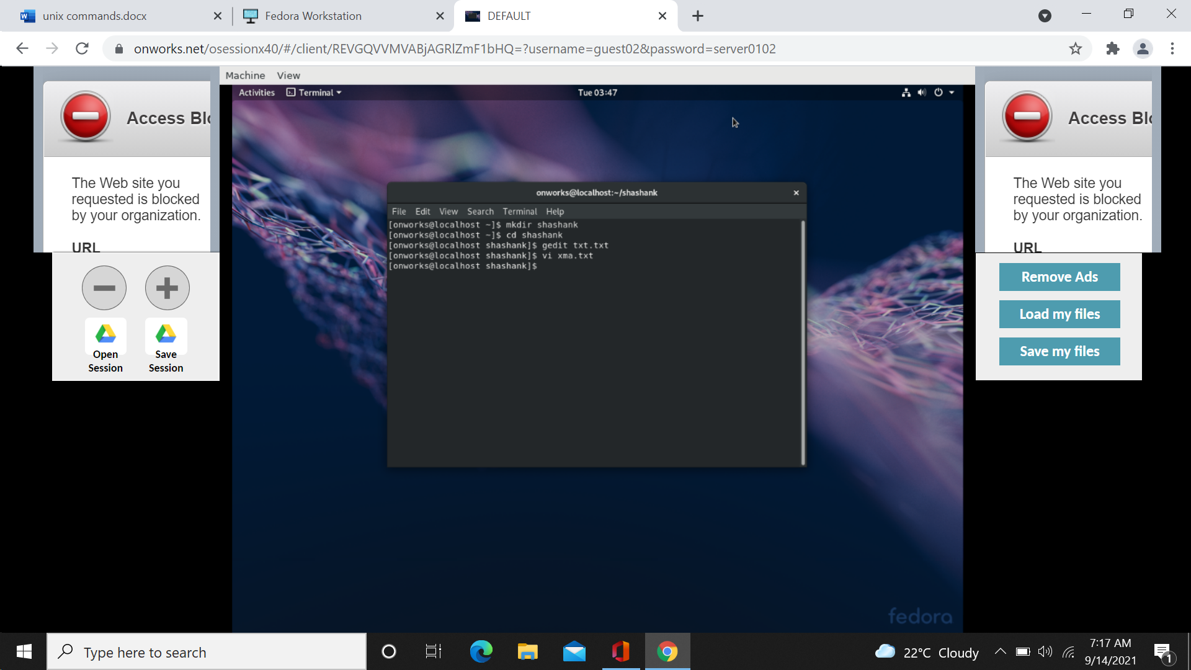

9.kill command: this command is used to remove the process.

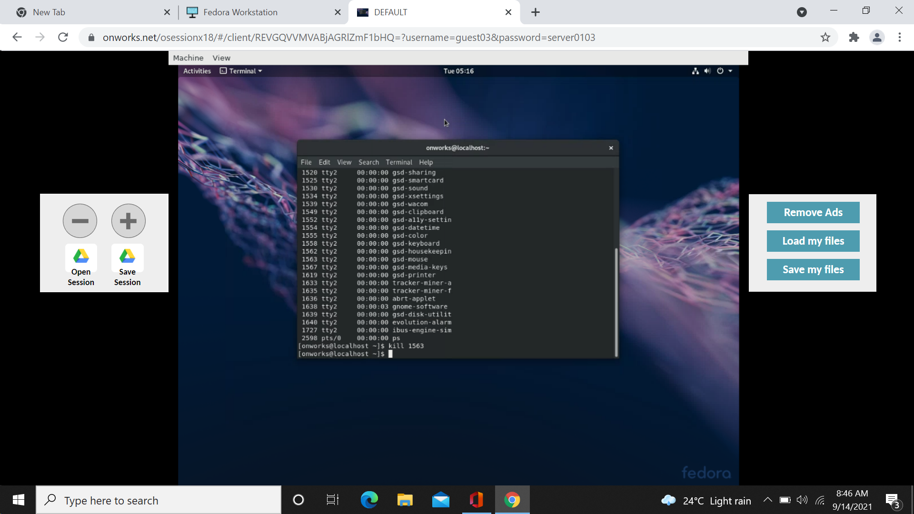

10.free: memory usage statitics.

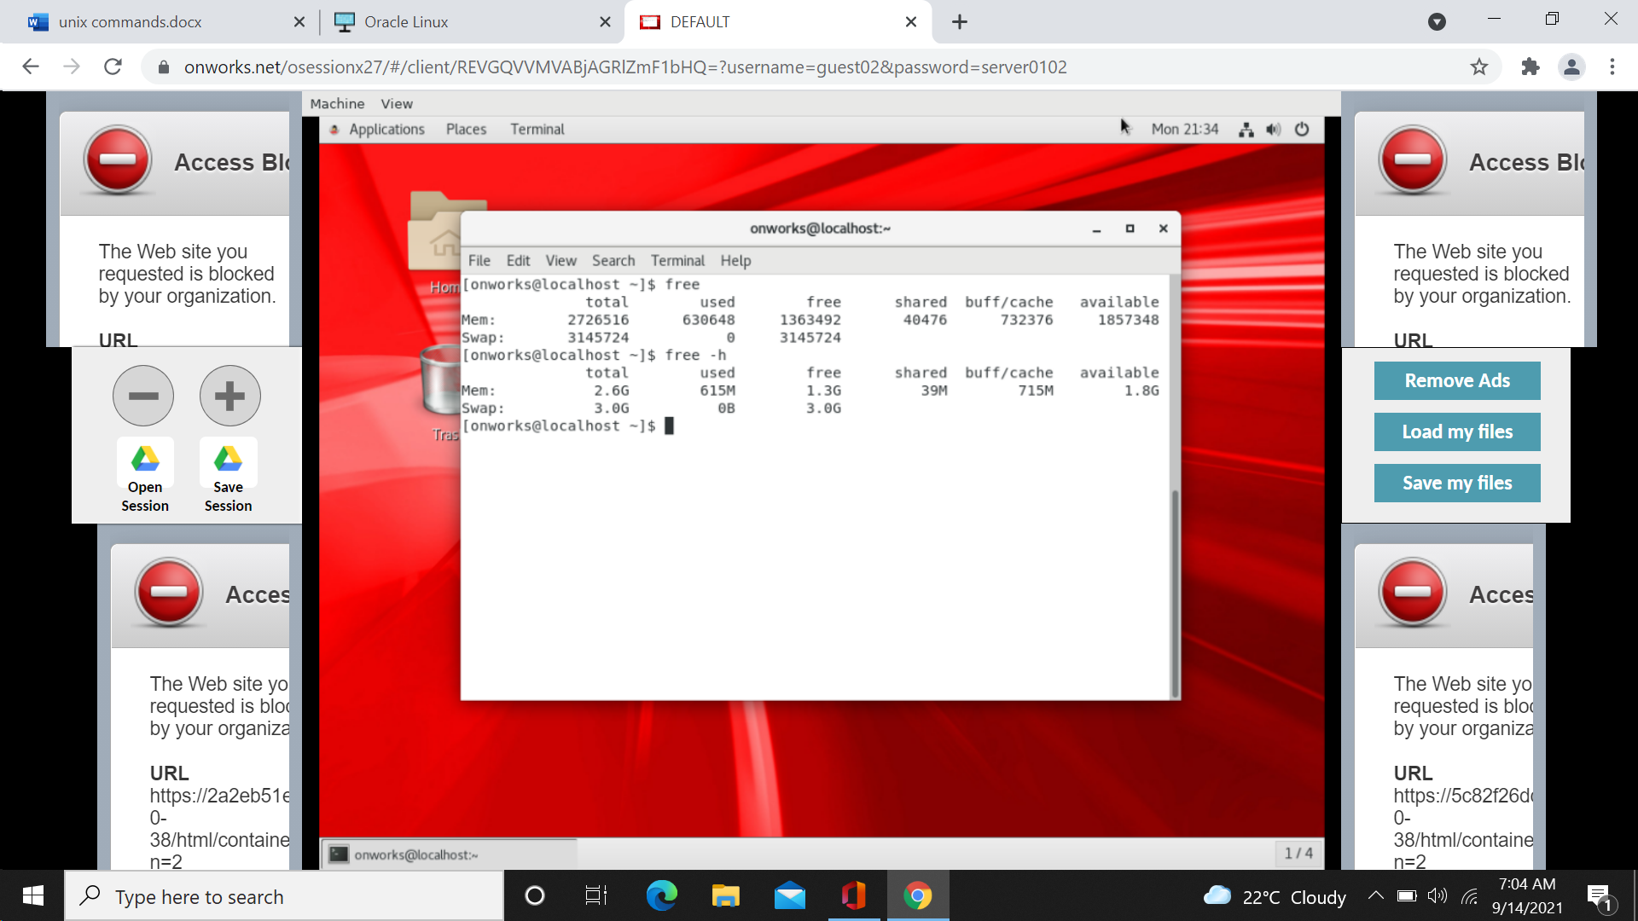

11.top command: user and system processes are listed here.

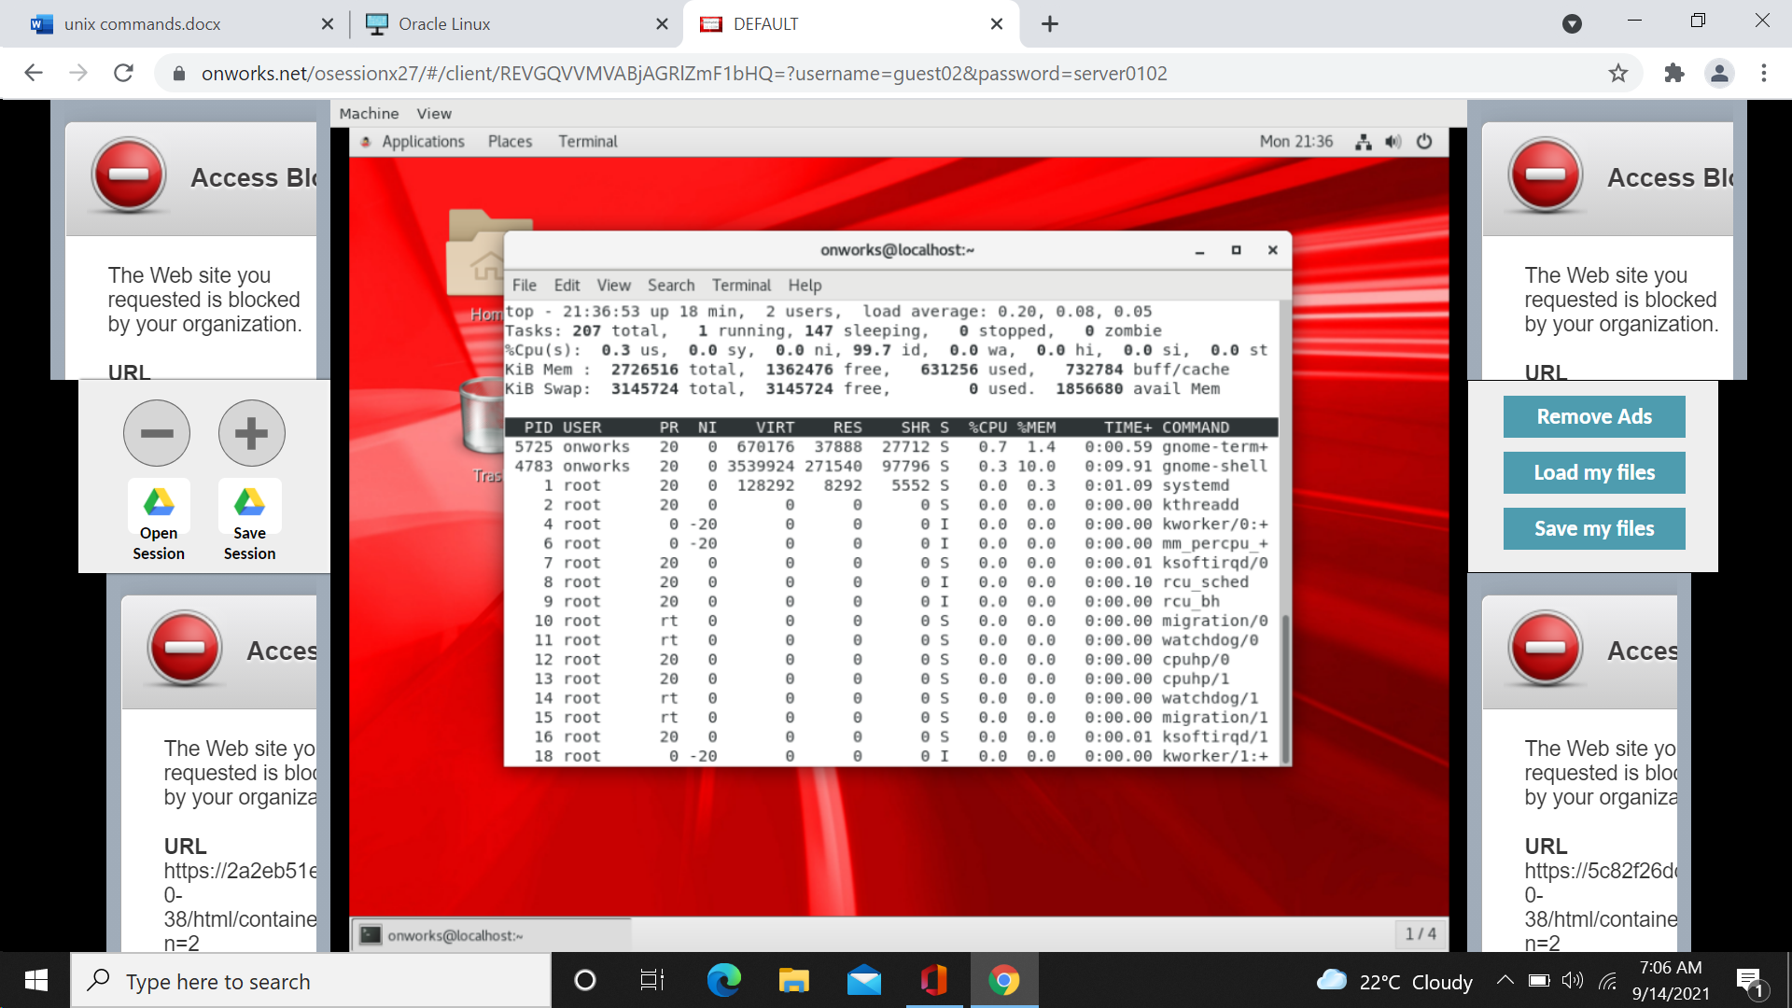

12.echo command: displays messages.

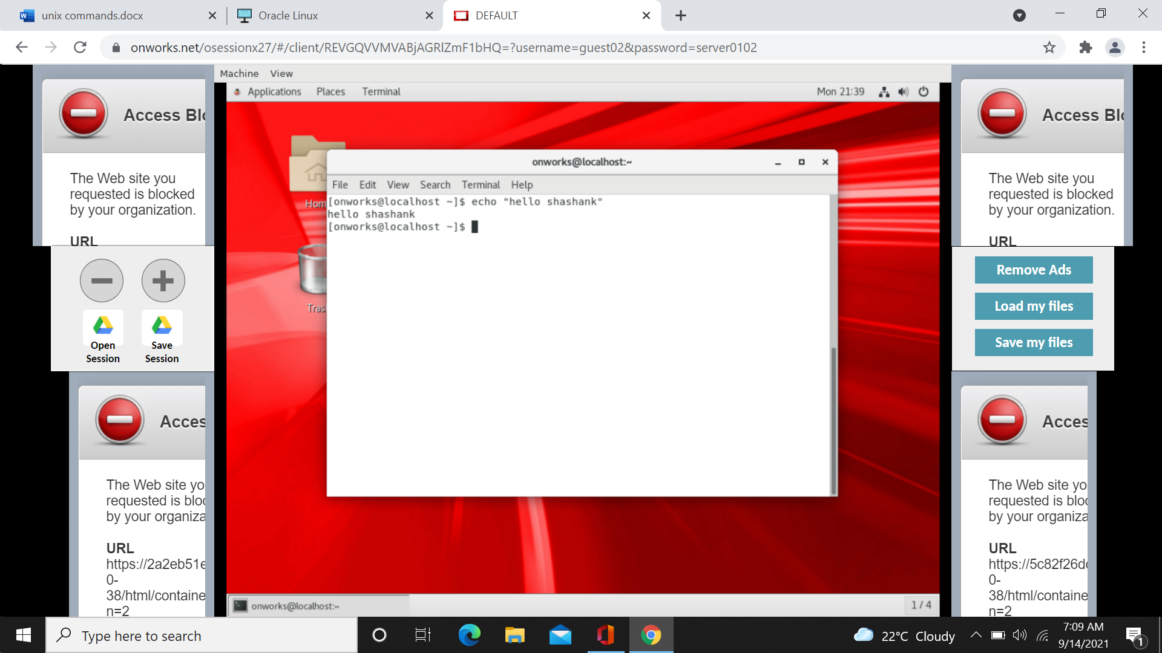

Rmkdir command and rm command: removes the content and directory.

